International Flavors & Fragrances Inc.

Solution Design Assessment

International Flavors & Fragrances Inc.

1.0 Overview
The purpose of this document is to serve as a design reference, blueprint for business requirements and security assessment. For the technical solution design document to be completed the following documents need to be delivered for International Flavors & Fragrances Inc.

- Project Introduction
- Vendor Risk Assessment
- Solution Design Assessment (this document)

Each section contains notes, considerations, and suggestions to guide a solution architect, security architect and governance teams. Depending on the type of project, e.g. internally or externally sourced, some components may be optional or completed from suppliers documentation. Sections can be renamed, as appropriate, to suit the type and complexity of the project.

Solution/Service Name (SaaS/IaaS): Software to provide scientific analysis of chemical structure
Vendor Name: ChemicalAI
Vendor Contact: Dohee Lee
Vendor Email: dohee.lee@chemical.ai
IFF Requester(s): Jack A. Bikker
CRC Contact: Senthil Kumar
Effective Date: Aug 06, 2026
ServiceNow Ticket: TASK1538919

1.1 Product Overview
This section is flexible in that components may or may not be included depending on the complexity of the project and whether it is sourced/developed internally. Provide sufficient detail to allow a technical build document to be generated by IT using this document as a base. The depth of detail is dependent on the relationship of the solution to the existing system. For example, a new report will follow well defined conventions and elements whereas a third-party application will only have higher level design elements, or none.

1.1.1 Please provide a description of the solution
ChemAIRS is an AI-driven retrosynthesis and chemical-synthesis analysis platform — a containerised (Kubernetes) micro-services web application. In this engagement it is deployed inside IFF's own AWS environment.

1.1.2 Please detail capabilities and Features
Please detail capabilities and Features
Retrosynthetic analysis engine (ML reaction-template extraction + neural ranking) generating scored routes; forward-synthesis prediction and synthesizability (SA) scoring; impurity prediction; process-chemistry module (cost, solvent/reagent, scale-up); Bayesian optimisation of conditions. Optional BB and ELN integration.

1.1.3 Please detail any available options
Please detail any available options
Two deployment models: Chemical.AI-hosted SaaS, or customer-hosted (on-prem or customer cloud — this engagement).

1.1.4 When is the solution ready for testing and for a security review to verify this questionnaire?
Please explain / comment
Available for security review now (documentation, pen-test report, questionnaires).

1.1.5 Does your solution need to connect to IFF Applications (example SAP)?
☒ No
If Yes, Please explain / comment
Comment here

1.1.6 Required Environments
☒Production
☒Quality Assurance
☒Development
☐Training
☐Lab (POC)
☐OT (Operational Technology)
1.1.7 Is High Availability a requirement?
☒ Yes
If Yes, Please explain / comment
Comment here

1.1.8 Do you Require Network Connectivity?
☒ Yes
Please explain / comment
Comment here

2.0 Architecture & Technology
2.1 Provide a description of your proposed solution architecture, including network components and diagrams. Include a description of telecom requirements and how the solution will interface with existing technology.
Please explain / comment
ChemAIRS is organized into four logical layers: Access, Middleware, Computing, and Database (Figure 1 and Table 1). Users authenticate through the Auth Platform and submit tasks via the Application. Computational tasks are queued in RabbitMQ and consumed by compute services, with progress and transient workflow state tracked in Redis (Figure 1 and 2). Reference chemistry lookups are performed against the ChemicalInfo database, and final user-visible results are persisted in the business database (chemairs).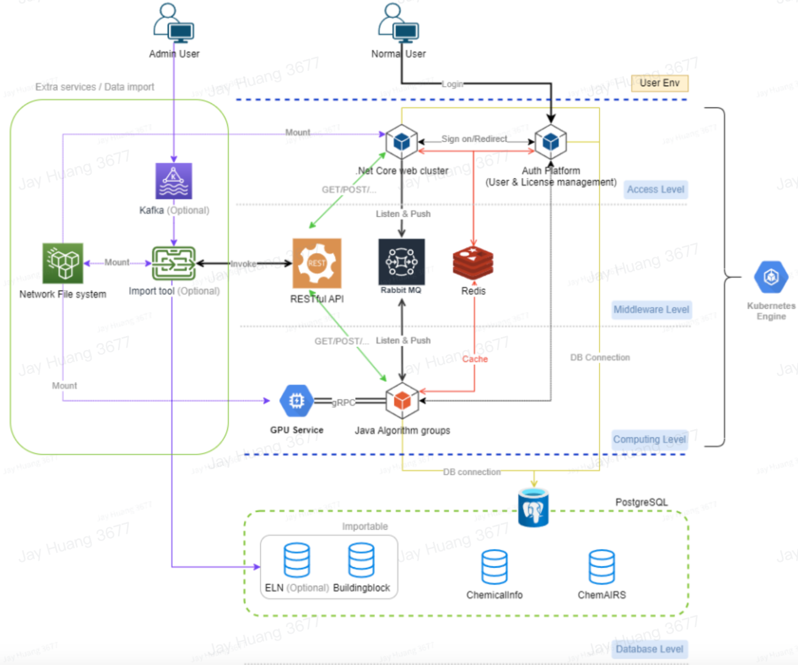

2.2 Describe historical reliability and availability statistics as well as capabilities provided in the event of down time or telecom failures.
Please explain / comment
Recovery objectives RTO ≤ 4h, RPO ≤ 1h; multi-AZ HA and load balancing. For this option, uptime depends on IFF's AWS infrastructure.

2.3 Describe system capability in generating automated alerts when experiencing downtime or connectivity issues for any external interface or application exceptions emanating from core platform.
Please explain / comment
For local deployment, it depends on IFF's AWS infrastructure

2.4 Explain the on-boarding process for new customer’s and how you go about learning their environment Explain the level of documentation?
Please explain / comment
Environment prep → deployment → validation/acceptance
Documentation: installation/deployment specs, user manuals, technical architecture, and O&M plans.

2.5 Is there a monthly review with customers to discuss issues, status and proactive recommendations as well as three moth planning and 6 months planning and adjustments? Is this included as part of your service?
☒ Yes
Please explain / comment
Regular review cadence can be arranged; scope of recurring reviews is a commercial matter

2.6 Do you have a try before you buy program, where customers can test certain capabilities before they commit to purchase?
☒ Yes
If Yes, Please explain / comment
Evaluation/trial access or a scoped POC can be provided before commitment

2.7 What proprietary technology (hardware and software) is needed for this system?
Please explain / comment
ChemAIRS containerised software; GPU compute for AI models; PostgreSQL; standard AWS services. No proprietary hardware required.

2.8 How are upgrades to the application and or hardware delivered?
Please explain / comment
Container-image based; delivered onsite, remotely, or self-service. Major releases twice per year.

2.9 Describe how system performance is impacted by the new solution
Please explain / comment
Runs in IFF's dedicated environment, sized to workload (GPU for model compute); isolated from IFF's other systems, so minimal external impact.

2.10 How geographically distributed is the user base?
Please explain / comment
IFF to define

2.11 What is the strategic importance of this system to other user communities inside or outside the enterprise?
Please explain / comment
IFF to define

2.12 What computing resources are needed to provide system service to users inside the enterprise? Outside the enterprise and using enterprise computing assets? Outside the enterprise and using their own assets?
Please explain / comment
Kubernetes cluster plus GPU node(s) and PostgreSQL in IFF's AWS; exact sizing depends on user count/workload, and joint scoping with Jay.

2.13 How can users outside the native delivery environment access your applications and data?
Please explain / comment
Browser over HTTPS with SSO; access controllable by IP/VPN via IFF's AWS security groups.

2.14 Is this a SAAS solution?
☒ No
If Yes, does the vendor provide other offerings like an on-premise solution.
Comment here

2.15 Does the vendor host the infrastructure themselves or is the data center provided by a third party Please provide details about data center.
☒ No
If Yes, please explain / comment
Comment here

2.16 Where are the Data Centers located.
Please explain where the data centers are located
The AWS region chosen by IFF (their AWS account). IFF controls data residency.

2.17 Do you provide automatic load-balancing, across data centers?
☒ Yes
Please explain / comment
Comment here

2.18 How do you control access to the data center?
Please explain / comment
AWS-managed physical DC controls (inherited, SOC/ISO-audited); logical access to the AWS account controlled by IFF.

2.19 Do you have any camera systems in place?
Please explain / comment
Inherited from AWS data-centre controls; not applicable to Chemical.AI.

2.20 Describe your physical protections for servers and network equipment.
Please explain / comment
AWS physical security (SOC/ISO-audited) within IFF's account; no Chemical.AI-operated server room in scope.

2.21 Does solution make use of interfaces other than secure web browsing. Like API's, EDI, IoT, File shares, Mail, FTP, etc?
☐SFTP
☐SSH-SC
☒HTTPS
☐FTPS
☒API
☐IPSec
☒Browser
☐PgP

Please explain / comment
Comment here

2.22 Does solution support mobile platforms?
☒ No
If Yes, provide details
Web UI works in mobile browsers; no dedicated native mobile app.

2.23 Does solution require a special setting, web browser add-on, additional software, or devices on IFFs infrastructure.
☒ No
If Yes, provide details
Comment here

2.24 Describe your solution’s system administrator capabilities.
Please explain / comment
Admin console for user/role management, configuration, and audit-log review/export. Maintenance admin roles do not include data access.

2.25 Describe your systems management tools
Please explain / comment
For local deployment, it depends on IFF's AWS infrastructure

2.26 Describe Administrative tools for monitoring and filtering of alarms
Please explain / comment
For local deployment, it depends on IFF's AWS infrastructure

2.27 Describe how your company monitors Data Center Availability?
Please explain / comment
For local deployment, it depends on IFF's AWS infrastructure

2.28 Describe remote monitoring of the OS, Connectivity, capacity management? Describe monitoring application outside of the standard server monitoring (e.g., windows service, web services, web sites, etc.)?
Please explain / comment
For local deployment, it depends on IFF's AWS infrastructure

2.29 What types of management or monitoring reports are available for customers?
Please explain / comment
Audit-log exports, monitoring dashboards, fully managed by IFF.

2.30 Describe the current roadmap of new and enhanced features to your platform and expected GA (Generally Available) date (actual or by Quarter’YR). Please provide a visual timeline of this roadmap as appropriate.
Please explain / comment
Continuous release cycle (two major updates per year); roadmap available on request.

2.31 Describe your implementation strategy
Please explain / comment
Environment prep → deploy containers → configure → validate/acceptance sign-off.

2.32 Average time frame of implementation
Please explain / comment
Typically a matter of weeks.

2.33 Responsibilities of IFF during implementation
Please explain / comment
Provide the AWS environment, IT/DevOps liaison, and acceptance testing. More details are to be determined.

2.34 Resources required from IFF
Please explain / comment
Provide the AWS environment, IT/DevOps liaison, and acceptance testing. The Engineers/ DevOps from IFF must have solid knowledge of k8s, Docker and AWS resources.

2.35 Describe your company's ability to provide pre-installation and post-installation consulting.
Please explain / comment
Deployment support, configuration, training, and ongoing maintenance support

2.36 Describe any services that your company offers to complement the proposed solution.
Please explain / comment
Training, custom deployment support, and integration support.

2.37 Identify and describe the role of any third parties that your company plans to employ to implement all or specific parts of the proposed solution.
Please explain / comment
None — implemented in-house by Chemical.AI (AWS is IFF's own provider).

2.38 Describe your company's process for documenting the system deployment, including relevant system configuration and customization.
Please explain / comment
Installation specs, configuration records, version control via GitLab/Harbor, and acceptance sign-off.
3.0 Cyber Security
The goal of cyber security design in the SDA is to ensure cyber security is an integral part of the information system solutions developed. All cyber security requirements should be identified at the requirements phase of a project and justified, agreed and documented as part of the overall business case for an information system. The business requirements for new solutions, or enhancements to existing solutions should specify the requirements for cyber security controls. The risk management process can be used to identify the requirements for cyber security controls. Specifications for solutions should consider both automated controls and the need for governance processes to support manual controls. This also needs to be considered when evaluating software, both developed and purchased. The cyber security requirements and controls should reflect the business value of the information assets involved, and the potential impact to IFF should a failure or absence of security occur. Purchased products need to undergo a formal testing and acquisition process that includes security functionality.

3.1 Do you have a policy for logging security violations?
☒ Yes
If Yes (Please Provide details)
Security events are captured in audit logs and reviewed regularly; logs are encrypted with ≥1-year retention (configurable by IFF in their environment).

How often are they reviewed?
Please explain / comment
For local deployment, configurable by IFF in their environment

3.2 What security tools are in place for detecting malware, breaches, or other hacker activity?
Please explain / comment
For local deployment, it depends on IFF's AWS infrastructure

3.3 Will any work being performed for IFF be sub-contracted to another firm?
☒ No
Please explain / comment
Comment here

3.4 If yes to previous question, what is your process for verifying their security?
Please explain / comment
Comment here

3.5 Is there a service or SIEM in place?
☒ No

3.6 Describe the process for log review and log retention?
Please explain / comment
Not applicable for local deployment. The local deployment contains an admin console for IFF admin to check logs for IFF users.

3.7 Do you require disk encryption on your end-point devices?
☒ No
Please explain / comment
Comment here

3.8 Do you perform a risk assessment? If yes, what standard is used?
☒ Yes
Please explain / comment
ISO 27001:2022 / ISO 27005-aligned methodology (5×5 likelihood × impact).

3.9 Describe your change management process, including methods for backing out changes?
Please explain / comment
Formal change control with dual approval (development + data-security leads), tested in pre-release; versioned container images enable rollback.

3.10 Describe the notification process and service level expectations outside of normal business hours?
Please explain / comment
Not applicable for local deployment.

3.11 Describe how your company’s customer service is organized and how it operates
Please explain / comment
Dedicated business manager plus support team, escalating to DevOps and development leaders.

3.12 Options for help desk availability and response times
Please explain / comment
Response within 1 business day; hours per agreement.

3.13 How is your help desk reached?
Please explain / comment
Via email and a dedicated business-manager contact.

3.14 Process for handling escalations
Please explain / comment
Tiered: support → DevOps/development leaders → management.

3.15 Describe the level of experience of your company’s help desk personnel
Please explain / comment
Technical staff including security experts and DevOps engineers.

3.16 Availability and requirements for remote support
Please explain / comment
Remote support with IFF authorisation; access is time-limited and logged.

3.17 Describe how support will be provided and coordinated for any aspects of your solution that are to be supported by a third party?
Please explain / comment
Not applicable

3.18 Describe the SLAs supported by your organization and any compensation provided for missed delivery.
Please explain / comment
To be determined

3.19 Does your company provide a public website to view outages (current & historical)?
☒ No
If Yes, please explain / comment
Comment here

3.20 Are upgrades included in the subscription fees
Please explain / comment
Yes

3.21 How and how often upgrades are conducted
Please explain / comment
Periodic major releases (twice per year); onsite/remote/self-service

3.22 Describe the responsibilities your company takes to implement patches or updates. Are they tested and certified in your lab?
Please explain / comment
Patches/updates are tested in QA/pre-release clusters replicating production before release; container-based delivery.

3.23 Describe your escalation procedures for critical issues and how IFF is kept informed throughout the process.
Please explain / comment
Documented incident process with email notifications and status updates throughout.

3.24 Describe your company's test environment resources available for pre-testing any proposed changes to the system.
Please explain / comment
Separate DEV/Test/QA and pre-release clusters that replicate production.

3.25 Describe monitoring and reporting of patch management?
Please explain / comment
Trivy/SonarQube reports and email notifications of vulnerabilities and fixes.

3.26 What are the considerations around using the application from off IFF internal network?
Please explain / comment
Access via HTTPS + SSO; restrictable by IP/VPN through IFF's AWS security groups.

3.27 Physical or logical access to systems by suppliers for support should be monitored and changes authorized using the change management process. Protection of system test data and access to program source code security control. Is this system managed by a third party if so who and how do we contact them. How do they access the system and who in IFF do they report to.
Please explain / comment
Chemical.AI support access is IFF-authorised, time-limited and logged, with no standing access; coordinated with IFF IT.

3.28 Do you require any exception from industry security standards, and why is this required?
Please explain / comment
None requested.

3.29 What level of OS patching is requested. Does any group need to be consulted about the timing of patching. How is third party application going to be patched?
Please explain / comment
OS patching is IFF's (they own the infrastructure); Chemical.AI advises.

3.30 Will solution send emails?
☒ No
If yes, describe destination, content, source name, and Domain
Comment here

3.31 How do you provide communication on Service Standards and results?
Please explain / comment
Reports, periodic reviews, and email notifications.

3.32 What service level guarantees are offered? (problem severity / types and definitions of severities)?
Please explain / comment
Chemical.AI classifies issues into four severity levels with corresponding response targets: S1 (Critical) — service down or unusable for all users with no workaround — responded to within 1 business day; S2 (High) — a major function severely impaired or degraded for many users with limited workaround — within 1 business day; S3 (Medium) — a minor function affected with a workaround available and limited user impact — within 1 business days; and S4 (Low) — cosmetic issues, questions, or enhancement requests — addressed in the next release cycle or as scheduled.

3.33 Describe the response time standards for the various types of incidents reported?
Please explain / comment
Response within 1 business day

3.34 What is your process when SLAs are not met?
Please explain / comment
Per contract

3.35 Is there compensation for Failure to meet Service level guarantees?
☒ No
If Yes, please explain / comment
Comment here

3.36 Describe the how many current or future users need to use the application in a mobile capacity or who need to work off-line.
Please explain / comment
IFF to define.

3.37 Explain your process for applying vendor security patches? What is the standard number of days for applying these patches?
Please explain / comment
High-risk fixes applied before release; application images regularly; risk-based remediation for other findings.

4.0 Identity and Access Management
4.1 Explain which and how roles and responsibilities will be defined and implemented for the new solution.
Please explain / comment
Role-based access control (e.g., researcher, project manager, administrator), defined at deployment and enforced in-app.

4.2 Describe the security features of your solution including the number of places requiring a login.
Please explain / comment
Single SSO login via Entra ID for the web app; RBAC enforced in-app; API uses separate token authentication.

4.3 Does solution provide SSO integration with IFF via SAML 2.0 or OIDC?
Note: To be used to integrate the solution with IFF MFA authentication through MS Entra ID
☒ Yes
Provide details about authentication method, password policy, and MFA authentication
Comment here

4.4 Do you provide group mapping via SAML 2.0 or OIDC?
☒ Yes
If Yes, please explain / comment
Today: manual user pre-creation with SSO credential validation; SCIM/automated group mapping evaluated case-by-case.

4.5 Explain your Identity and access management?
Please explain / comment
RBAC with least-privilege and separation of duties; individual accounts; privileged access requires approval; all access audit-logged; integrates with IFF's Entra ID.

4.6 Do end users share user IDs or authentication in applications?
☒ No
If Yes, please explain how and why
Comment here

4.7 What authentication services do you support?
Please explain / comment
Azure AD/Entra ID (SAML 2.0 / OAuth 2.0 / OIDC), LDAP, local password auth, and API token/key.

4.8 Privileged Access Requirements
Is Privileged Access (administrator access) required, why is it needed and who must have access?
Please explain / comment
Administrator access is needed for user/role/configuration management (not data access), held by IFF-designated admins. Chemical.AI support access is IFF-authorised and time-limited.

4.9 User Access Management
Define the owners and groups for the application/system and the generic, administrative and/or system user logins and their functions, if any. Identify the job position that has ownership and administrative responsibility for the application/system.
Please explain / comment
An IFF-designated system owner and tenant administrator manage the account lifecycle; Chemical.AI assists. Admin responsibility sits with IFF's designated role.

4.10 File System Access Control
What access control rules or methods are in use to ensure that access is only granted to users with a legitimate need to access files and data?
Please explain / comment
RBAC least-privilege; non-administrative database roles are read-only; encrypted storage; access audit-logged.

4.11 Third Party Management and Access
Physical and Environmental Security
In case of an In-house solution, how are you securing the Servers and Infrastructure from unauthorized access? Are there any special considerations to enter the DC or server room?
Please explain / comment
Hosted in IFF's AWS (AWS physical controls inherited); no Chemical.AI server room in scope. Logical account access controlled by IFF.

4.12 Will Third Party (non-iff) access be required?
☒ No

5.0 Data Security
5.1 Define any output artifacts such as reports, files, screen displays, data transfers to database tables, or third party applications, etc. Include comments regarding frequency of output or transfer and any requirements to automate processes, such as overnight batch processing.
Please explain / comment
Synthetic-route reports, SA scores, JSON/CSV/Excel exports, audit-log exports.

5.2 Define requirements for each environment including folder structures, file store locations, database elements ‐ schemas, tables, packages, triggers and sequences, as applicable.
Please explain / comment
PostgreSQL schemas (ChemAIRS main, Auth-Platform, ChemicalInfo, Building-block) and container volumes/NFS. Detailed in the installation spec.

5.3 Provide estimates on the volume of data to be transferred to and from the solution. This should include size for current demands and future growth.
Please explain / comment
IFF to define (usage-dependent).
5.4 Describe how the solution will cope if access to the Master Data is unavailable for a period of time. Address specific situations such as how the solution will respond if user authentication information is unavailable. This can become a problem for the application where services to select from Master Data are to be used. IF MDR becomes unavailable, this will need to be catered for in the application.
Please explain / comment
ChemAIRS separates its authentication/identity layer (the Auth-Platform, federated to IFF's Entra ID for SSO) from its application and reference-data layers, so a disruption in one does not cascade across the system. If the identity source is temporarily unavailable, new single-sign-on logins will be affected for the duration, but the failure is contained and handled gracefully rather than causing an application crash; users already holding valid sessions are unaffected until their session expires, and normal login resumes automatically once the identity source is restored. In the customer-hosted (Option 2) deployment, these components run within IFF's own AWS environment, so availability of the identity source and reference data also depends on IFF's infrastructure and network.

5.5 When using Master Data within the Solution’s own schemas. How quickly will this data have to be refreshed? Eg real time, within an hour, overnight etc. Is there the potential for an adverse effect on performance where a data transfer is running between datacenters?
Please explain / comment
Building-block/chemical-info databases updated per release or import. Refresh cadence: IFF to define.

5.6 Define the owners and groups for the application/system and the generic, administrative and/or system user logins and their functions, if any. Include any third party access requirements. Identify the job position that has ownership and administrative responsibility for the application/system.
Please explain / comment
As 4.9 — IFF-designated owner and tenant administrator.

5.7 Business Requirement for Access Control. Define access control policy
Please explain / comment
RBAC least-privilege; documented access-control policy.

5.8 Can IFF readily export or import its data in one or more well-known and usable industry formats.
☒ Yes
If Yes, please explain / comment
Comment here

5.9 Can the data be accessed by IFF owned tools outside of those provided by the vendor?
☒ Yes
Please explain / comment
Comment here

5.10 Can the data be replicated to an IFF data center?
☒ Yes
Please explain / comment
IFF has a full control of its own data

5.11 Provide specifics on how the provider will use IFF data (including internal analysis)
Please explain / comment
None — Chemical.AI does not access or use IFF data, and IFF data is never used to train models

5.12 Describe how backups are stored? For example, off-site, fireproof cabinet, etc.
Please explain / comment
IFF controls storage.

5.13 Describe your back-up and archiving process for intermediate and full backups?
Please explain / comment
IFF controls storage

5.14 Are back-up and archiving encrypted?
☒ Yes

5.15 How often are restore procedures tested?
☒ Yes
If Yes, please explain / comment
Quarterly.

5.16 Do you have commitments to retain data due to legal and business requirements? If yes, please provide supported compliance models?
☒ Yes
If Yes, please explain / comment
Configurable retention supporting IFF's retention needs; ISO 27001-aligned.

5.17 Does the application support role-based access?
☒ Yes

5.18 Is the application configurable by IFF?
☒ Yes

5.19 Are there any controls to stop company information from being placed onto removable media devices (such as USB drives or laptops)?
☒ Yes
If Yes, please explain / comment
In-app export is RBAC-controlled and audited; endpoint/removable-media controls are enforced by IFF's own device policies.

5.20 Will any third party companies have access to IFF data?
☒ No
Please explain / comment
Comment here

5.21 Do you encrypt all IFF data at rest?
☒ Yes
Please explain / comment
Not applicable for local deployment

5.22 Do you encrypt all IFF data in motion/transit?
☒ Yes
Please explain / comment
Not applicable for local deployment

5.23 Can IFF manage the encryption keys?
☒ Yes
Please explain / comment
Comment here

5.24 Does the data need to be Encrypted
☒ Yes

5.25 Do you support both logical and physical encryption?
☒ Yes
If yes, please describe how each is implemented, including examples of services or infrastructure components that use logical (e.g., IAM policies, software-based encryption) and physical (e.g., HSMs, dedicated hardware) encryption.
Please explain / comment
Comment here

5.26 What are the data retention requirements? [SOX / PCI / Any Regulatory requirements for Financial Data]
Please explain / comment
For local deployment, IFF has full control of the data

5.27 Databases are required for <Dev/QA/Staging/Test/Prod/DR> Environments
Please explain / comment
Separate database instances per environment.

5.28 How often would you like to refresh your DB data?
☒ Not Applicable

5.29 How often would you like Backup retention?
☒ Not Applicable
Please Comment if Not Applicable
Comment here

5.30 Any Specific RTO requirements for the Databases for Production/DR environments?
☒ Yes
If Yes, please explain / comment
Not applicable for local deployment

5.31 Describe managed backup and restore services to included Daily, weekly and monthly backups?
Please explain / comment
Not applicable for local deployment
5.32 Describe how backups are verified and status is provided notifying IFF?
Please explain / comment
For local deployment, IFF has full control of the data

5.33 Describe data and file restore services?
Please explain / comment
For local deployment, IFF has full control of the data

5.34 Describe replication of backup data?
Please explain / comment
For local deployment, IFF has full control of the data

5.35 Business continuity fail over and fail back (RPO, RTO)
Business continuity provides a level of backup that will enable the service/application to be restored to working order in a defined period. What standby systems are available for fail over of the application services? How fail is over achieved and what procedures are in place to perform this process.
Please explain / comment
For SaaS, RTO ≤ 4h, RPO ≤ 1h; multi-AZ standby; documented recovery process.

5.36 Data Retention Requirements
Are there any archival requirements with logs or other created data? If any, what are the retention periods for this information? Remember backup storage is rotated so if you need data from a point in time greater than the frequency of the backups you need to specify this as an archival requirement.
Please explain / comment
Not applicable for local deployment. IFF to define.

5.37 Do you have SLAs for Disaster recovery?
☒ Yes
If Yes, please provide the SLA along with expected uptime percentage.
Not applicable for local deployment

5.38 Do you have customer data archiving and recovery solutions?
☒ Yes
If Yes, please provide the SLAs for archiving and recovery
Not applicable for local deployment

5.39 Do you store the client's data offsite to be viewed outside of the organization?
☒ No
If Yes, please explain / comment
For local deployment, IFF has full control of the data

5.40 Do you allow IFF to dictate priority of recovered customer data?
☒ Yes
If Yes, please explain / comment
For local deployment, IFF has full control of the data

5.41 Do you test full disaster recovery procedures, across multiple data centers, at least once a year?
☒ Yes
If Yes, please explain / comment
Quarterly backup/restore tests and bi-annual drills.

5.42 What external dependencies does this application have? What impact would an external outage have on the functions of the application? What depends on this system and how would an outage of this application impact on other systems.
Please explain / comment
Depends on AWS (IFF's account) and Entra ID for SSO; otherwise isolated from IFF's other systems.

6.0 Network Security
6.1 What access controls are to be implemented on the network level? Are there policies that relate usage from specific machines or locations?
Please explain / comment
AWS security groups and VPC segmentation; IP restriction; only ports 80/443 (80→443 redirect).

6.2 Describe your network or provide a network diagram showing your environment and any security devices?
(Paragraph)
Not applicable for local deployment

6.3 Describe your process for network monitoring.
Please explain / comment
For local deployment, IFF to define

6.4 Describe your process for providing remote access for your employees?
Please explain / comment
Not applicable for local deployment

6.5 Do you use a syslog server for network devices?
☒ Yes
Please explain / comment
For local deployment, IFF to define

6.6 Do you allow IP whitelisting?
☒ Yes

6.7 Do you allow IP blacklisting?
☒ Yes

6.8 Do you allow VPN services?
☒ Yes

6.9 Describe firewall and intrusion protection control needs
Please explain / comment
For local deployment, IFF to define

7.0 Application
7.1 Describe your SDLC process including types and frequency of security checks
Please explain / comment
SonarQube SAST on every commit; Trivy container scans on every release; OWASP scans; dual code review; annual third-party penetration test.

7.2 Describe your monitoring process for your application and services?
Please explain / comment
Grafana/CloudWatch, health checks, and web-service monitoring.

7.3 Does the application use a content accelerators / caching component?
☒ Yes
If Yes, please explain / comment
Redis caching (optional CDN).

7.4 Does the application have Virtualization constraints?
☒ No
If Yes, please explain / comment
Comment here

7.5 The application receives data from which Sources?
Please explain / comment
User-input structures, building-block/chemical-info databases (locally deployed), and optional ELN/import.

7.6 The application will feed data to which Targets?
Please explain / comment
Reports/exports

7.7 The application has job scheduling requirements and will utilize Job Scheduler Name
Please explain / comment
Asynchronous task queue (RabbitMQ); batch jobs for bulk operations.

7.8 Which user sessions does the application maintain?
Please explain / comment
Authenticated web sessions (token/cookie-based).

7.9 Describe the processes that have a dependency on the infrastructure.
Please explain / comment
GPU compute, database, message queue, and cache.

7.10 Does this application require any Batch Processing
☒ Yes

7.11 What is the estimated # of concurrent users accessing the application?
Please explain / comment
IFF to define (licensed sizing).

7.12 The expected application response time is:
Please explain / comment
Interactive; complex model compute takes longer. Target: IFF to define.

7.13 The one year user growth rate is:
Please explain / comment
IFF to define.

7.14 The three year user growth rate is:
Please explain / comment
IFF to define.

7.15 The application has seasonal usage variations.
☒ Yes

7.16 What are the peak and non-peak performance periods?
Please explain / comment
IFF to define.

7.17 Describe and quantify the use of systems resources by application processes and threads.
Please explain / comment
Kubernetes-scaled; GPU for models; sizing per workload.

7.18 Are there any other 3rd party software constraints?
Please explain / comment
Standard open-source stack; no restrictive constraints.

7.19 List 3rd party software recommended minimum requirements:
Please explain / comment
Kubernetes, PostgreSQL, GPU drivers; per installation spec.

7.20 Can/does the presentation layer and application layers run on separate processors?
☒ Yes

Please explain / comment
Comment here

7.21 Can/does the application layer and data access layer run on separate processors?
☒ Yes

7.22 Can this application be placed on an application server independent of all other applications? If not, explain the dependencies.
☒ Yes
Please explain / comment
Comment here

7.23 Can additional parallel application servers be easily added? If so, what is the load balancing mechanism?
☒ Yes
Please explain / comment
Comment here

7.24 Will the application will utilize SAN or cloud storage?
☒ Yes

7.25 What is the expected storage growth rate over the next year?
Please explain / comment
IFF to define.

7.26 Will storage need to be shared between different components and tiers?
☒ Yes
If Yes, please explain / comment
Shared database/NFS as needed.

7.27 How many concurrent users are expected to connect to the database?
Please explain / comment
IFF to define.

7.28 Does the application require URL monitoring?
☒ Yes
If Yes, please explain / comment
Comment here

7.29 Does the application require web service monitoring?
☒ Yes
If Yes, please explain / comment
Comment here

7.30 Does the application require web usage reporting?
☒ Yes
If Yes, please explain / comment
Comment here

7.31 What application processes and services will need monitoring?
Please explain / comment
Web, API, GPU, database, queue, and cache.

7.32 What application logs will need monitoring?
Please explain / comment
Application, security, and audit logs.

7.33 What URLs will need monitoring?
Please explain / comment
Application frontend and API endpoints.

7.34 What other applications and/or systems require integration with yours?
Please explain / comment
Optional, IFF to define.

7.35 Describe the integration level and strategy with each application.
Please explain / comment
API-based (REST/JSON), SSO federation, and file import/export.

7.36 Please provide context diagram is to be provided showing how the solution integrates with other applications. Also include any sources that may be required for master data.
Please explain / comment
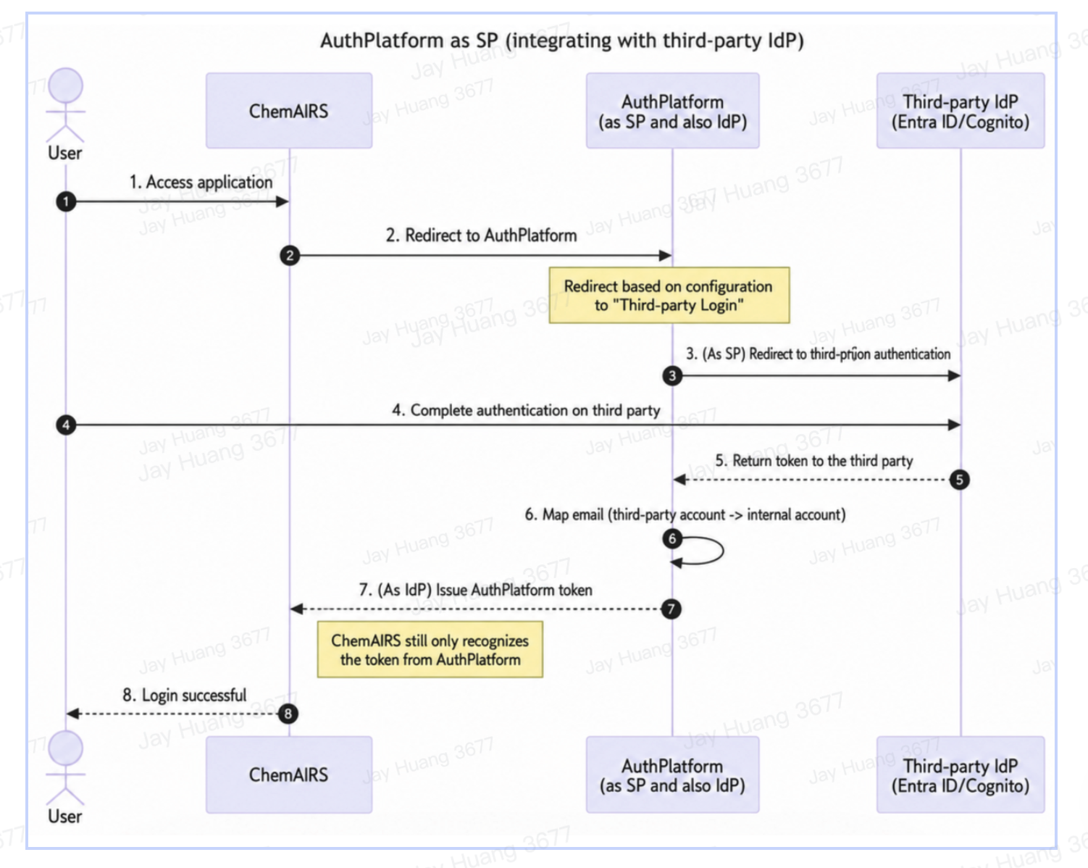
7.37 Does the vendor have a release cycle for application enhancement?
☒ Yes
If Yes, what is the release cycle and how will they be communicated
Comment here

7.38 Does the vendor have a release cycle for bug fixes?
☒ Yes
If Yes, what is the release cycle and how will they be communicated
Hotfixes as needed, communicated by email.

7.39 Are we required to accept enhancements?
☒ No
Please explain / comment
For customer-hosted, IFF controls when to apply updates.

7.40 Could IFF support the application if we were required to bring the solution "in house"?
☒ Yes
Please explain / comment
IFF operates the deployed instance post-deployment with Chemical.AI support; source/algorithm remain Chemical.AI IP.

7.41 What is the typical length of requests that are transactional?
Please explain / comment
Interactive queries in seconds; complex route computation longer.

7.42 Do you need guaranteed data delivery or update, or the system tolerate failure?
Please explain / comment
Async queue with retry and audit trail; tolerant of transient failures.

7.43 Are there any logs produced by the application. What information is available in the log files and for what period are they required to be kept.
Please explain / comment
Application/security/audit logs; IFF to define the retention period.

7.44 What interfaces are available to start and stop the application. What documentation is available to operators to check the status of the application? Are there any checks or dependencies that need to be considered before the application can be started or stopped?
Please explain / comment
Standard Kubernetes/container controls; O&M documentation; health checks; documented dependencies (database, queue).

8.0 Client
8.1 Are functions other than presentation performed on the user device?
☒ No
If Yes, (Which functions?) Please explain / comment
Comment here

8.2 Describe the data and process help facility being provided.
Please explain / comment
In-app help and tooltips, user manuals, and support.

8.3 Describe the screen to screen navigation technique.
Please explain / comment
Standard web-UI navigation.

8.4 Describe how the user navigates between this and other applications.
Please explain / comment
Browser-based; SSO enables app switching.

8.5 How is this and other applications launched from the user device?
Please explain / comment
Via browser URL with SSO.

8.6 Are there any inter-application data and process sharing capabilities? If so, describe what is being shared and by what technique / technology.
☒ No
Please explain / comment
Optional — via API/ELN(or Buildingblock) integration.

8.7 Describe data volumes being transferred to the client.
Please explain / comment
Modest (query results/reports), rendered in the browser.

8.8 What are the additional requirements for local data storage to support the application?
Please explain / comment
None beyond browser cache.

8.9 What are the additional requirements for local software storage/memory to support the application?
Please explain / comment
A modern browser; no local install.

8.10 Are there any known hardware / software conflicts or capacity limitations caused by other application requirements or situations, which would affect the application users?
Please explain / comment
None known; standard browser.

8.11 Describe how the look and feel of your presentation layer compares to the look and feel of the other existing applications.
Please explain / comment
Standard modern web UI.

8.12 Describe to what extent the client needs to support asynchronous and / or synchronous communication.
Please explain / comment
Both — synchronous UI plus asynchronous task queue.

8.13 Describe how the presentation layer of the system is separated from other computational or data transfer layers of the system.
Please explain / comment
Micro-services; frontend separated from compute/data layers.

8.14 Describe the design that accommodates changes in the user base, stored data, and delivery system technology.
Please explain / comment
Horizontally scalable, containerised, and modular.

8.15 How are software and data configured mapped to the service and system configuration?
Please explain / comment
Version-controlled (GitLab) with configuration records. Deployment and infrastructure are defined as code via Helm and Terraform.

8.16 Describe how each and every version of the software can be reproduced and re-deployed over time.
Please explain / comment
Versioned container images, Helm and Terraform.

9.0 AI (Artificial Intelligence)
Only relevant for AI solutions. *** Solutions with AI Only ***

9.1 AI Model Summery and Transparency
a. Can you explain how your AI models arrive at specific decisions or outcomes?
Explain IA decision
Outputs are traceable to reaction precedent (template extraction + neural ranking); each proposed step is inspectable against the literature/patent it derives from. The core engine is not a generative LLM, so it is auditable rather than opaque.

b. What steps do you take to ensure transparency in AI-generated results?
Explain transparency on AI-generated results
Routes are scored for viability, cost and step count and traceable to source reactions; chemists review outputs before use (human-in-the-loop).

9.2 Monitoring of Input and Outputs:
a. How do you monitor the inputs provided to the AI system to detect potential malicious or abnormal inputs?
Input monitoring
Input validation/whitelisting, rate limiting, and audit logging of inputs.

b. How do you monitor and analyze the outputs of generative AI systems to ensure they comply with ethical guidelines and do not generate harmful or inappropriate content?
Output monitoring
Not applicable in the generative sense — outputs are advisory synthetic routes reviewed by chemists, not free-form generated content.

9.3 Anticipating Attacks and Threat Intelligence:
a. How do you use threat intelligence to anticipate potential AI-related security attacks or vulnerabilities?
Threat intelligence for identifying AI security attacks
Threat-intel feeds, container CVE scanning, and standard application-security controls.

b. What mechanisms do you have in place to proactively respond to emerging threats in AI systems?
Methods to respond proactively to emerging AI threats
Monitoring, patching, and security assessments.

9.4 Safe by Design and Default:
a. How do you ensure that your AI solution is designed with security in mind from the outset (safe by design)?
Please specify
Secure development lifecycle and ISO 27001 design/development controls; models operate on chemical-structure data only, with no personal data or profiling.

b. What security features are enabled by default in your AI solution (safe by default)?
Please specify
RBAC, encryption, and audit logging enabled by default; in customer-hosted deployment there is no external transmission of inputs, and customer data is never used for training.

9.5 AI Integrations:
a. How does your AI solution integrate with our existing security infrastructure?
Please specify
SSO/Entra ID, audit logs exportable to IFF's SIEM, and AWS-native controls.

b. What APIs or protocols are supported for seamless integration?
Please specify
REST/JSON API, SAML 2.0/OIDC, and HTTPS/TLS.

9.6 Incident Response and Recovery:
a. What is your incident response plan for AI-related security breaches or vulnerabilities?
Please specify
The same documented incident process applies, with email notification and defined RTO/RPO.

b. How quickly can you respond to and recover from AI security incidents?
Please specify
RTO ≤ 4h, RPO ≤ 1h; response within 1 business day.

9.7 AI Ethics and Bias:
a. How do you address issues related to bias in AI algorithms and data sets?
Please specify
Models are trained on curated public and licensed reaction corpora in the chemistry domain (not personal/social data); outputs are validated by chemists.

b. What steps do you take to ensure that your AI solution complies with ethical guidelines?
Please specify
The system operates on chemical-structure data only — no personal data, no profiling, and no automated decisions about individuals. All outputs are advisory, with a human in control of every decision (human-in-the-loop), and AI development is governed by Chemical.AI's ISO 27001-certified design and development controls.

9.8 AI Model Updates and Patch Management:
a. How do you handle updates and patches for AI models to address security vulnerabilities?
Please specify
Versioned model releases under change control, delivered via container images.

b. How frequently do you release updates, and how are they delivered?
Please specify
Periodic releases (two major releases per year); onsite, remote, or self-service.

10.0 OT (Operational Technology) Questions
Relevant for OT solutions (factory and R&D solutions). *** OT Solutions Only***

10.1 Monitoring of Input and Outputs:
a. How do you monitor the inputs provided to the OT systems to detect potential malicious or abnormal inputs?
Please specify
Not applicable

b. How do you monitor the outputs of OT systems to identify anomalies or deviations from expected behavior?
Please specify
Not applicable

10.2 Anomaly Detection and Threat Intelligence:
a. What methods and technologies do you use for anomaly detection in the OT environment?
Please specify
Not applicable

b. How do you leverage threat intelligence to anticipate potential OT-related security attacks or vulnerabilities?
Please specify
Not applicable

10.3 Safe by Design and Default:
a. How do you ensure that your OT solution is designed with security in mind from the outset (safe by design)?
Please specify
Not applicable

b. What security features are enabled by default in your OT solution (safe by default)?
Please specify
Not applicable

10.4 OT Integrations:
a. How does your OT solution integrate with our existing IT and OT security infrastructure?
Please specify
Not applicable

b. What communication protocols and interfaces are supported for seamless integration with our current systems?
Please specify
Not applicable

10.5 Incident Response and Recovery:
a. What is your incident response plan for OT-related security incidents or breaches?
Please specify
Not applicable

b. How quickly can you respond to and recover from OT security incidents?
Please specify
Not applicable

10.6 OT System Updates and Patch Management:
a. How do you handle updates and patches for OT systems to address security vulnerabilities?
Please specify
Not applicable

b. What is your process for testing and implementing updates without disrupting critical operations?
Please specify
Not applicable

10.7 OT Ethics and Safety:
a. How do you address ethical concerns related to the use of OT systems in critical industries?
Please specify
Not applicable

b. What safety measures are in place to prevent accidents or malfunctions in the OT environment?
Please specify
Not applicable

Full Name: | Full Name: Jay Huang
Company: International Flavors & Fragrances Inc. | Company: ChemicalAI
Title: | Title: Platform Engineer
Signature: | Signature: Jay Huang

